**Working with the elastic beanstalk**

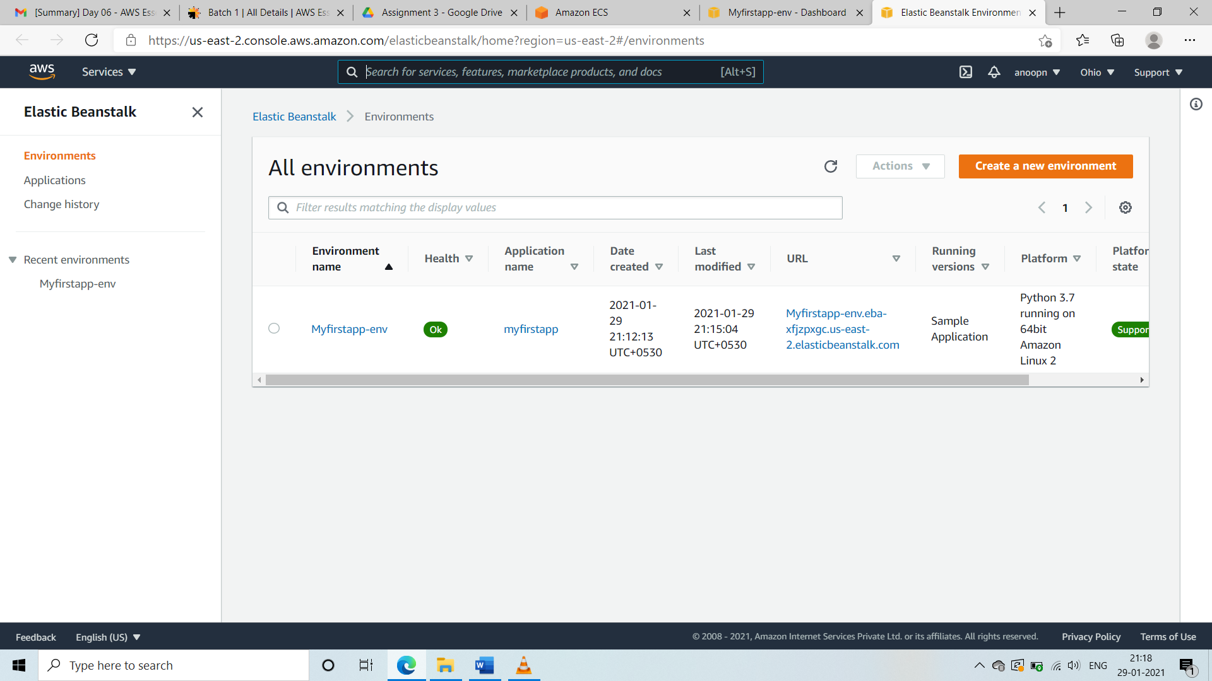

**SS1: ● Create an application**

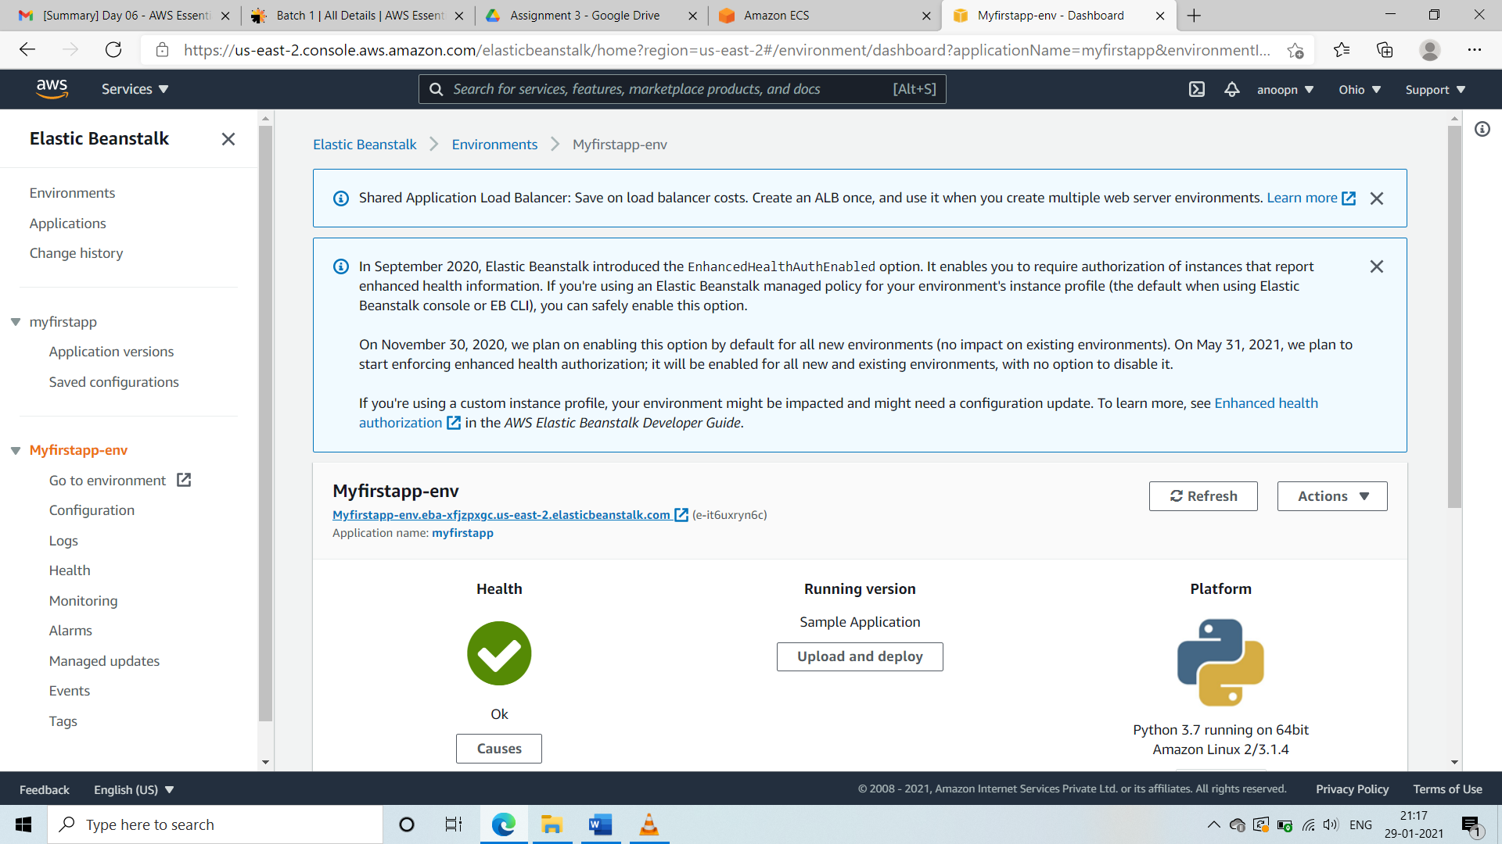

**SS2: ● Create an env with sample python/java**



**SS3: ● Access the deployed application with the env URL**